**CS 340 README Template**

**About the Project/Project Title**

Grazioso Salvare Animal Shelter Database. This program provides an interface for the team at Austin Animal Center to interact more efficiently with the database. The dashboard provides an easy way to view all animal records and filter animals down for specific needs. There is also a map which shows where a specific animal was located, and a pie chart which shows the number of and distribution of preferred breeds for rescue training.

**Motivation**

The Austin Animal Center is an international rescue-animal training company. The animals recruited to train in search and rescue come from all over the world and all walks of life. The company handles a large number of animals and must be stringent in its organization in order to efficiently recruit, train, and deploy support animals as needed when a search and rescue mission is occurring. For this reason, this program was created to support AAC’s efforts, by streamlining the database maintenance process.

**Getting Started**

The CRUD module was built using Python 3.12.7, the database was built with MongoDB 8.0.4, and the dashboard was built with JupyterDash 0.4.2. The version of JupyterDash used is depreciated, so Dash 2.11 would be appropriate.

1. Simply download the folder containing the program found here: <http://bit.ly/3OVPRmU>
2. You may need to install additional packages, if not already done so. If using the Terminal, any additional packages needed can be installed using **pip install** [package name]. Example: **pip install pymongo**
   1. Use [package name] **–v**, or **pip show** [package name] to verify installation and view version data.
3. Using the Terminal, run the command jupyter notebook, this will launch the browser window (or tab), but if it doesn’t work then copy and paste one of the provided URL’s
4. You should be able to open the file **ProjectTwoDashboard.ipynb**
5. Be sure to update values as appropriate, and special note that the working directory is hardcoded in at the top of the file, you must update or remove this as needed.

**Installation**

This program works via a connection to MongoDB, meaning you must have MongoDB installed or you can use a free account on the website [cloud.mongodb.com](https://cloud.mongodb.com/). You’ll have to get a database set up first, since you need to update the connection variables to work for your database. You will need to use the **mongoimport** command to create the database and import the AAC outcomes CSV file. However, if the intention is to use the dashboard and functionality with different data, be sure to update the code as needed to align with your needs.

Once your database is set up and you’ve changed the connection variables you will be able to run the program and start creating documents in the database! Note: in the code the animals would be referred to as objects (object-oriented programming), with MongoDB these objects are called documents!

**Usage**

When the program is first run there will be a user interface as shown below.

This interface can be removed by simply commenting out lines 121-261.

This interface provides the CRUD functionality from the python module and will loop continuously until the user quits by entering ‘q’.

1. Create record:

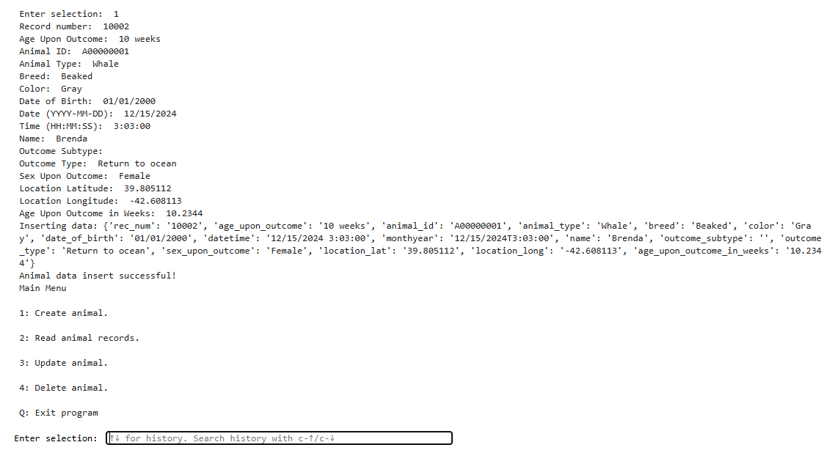

*Values shown here are for example purposes only

Create new animal records by inputing ‘1’, then fill out the information as prompted. Note that within the actual records there are ‘datetime’ and ‘monthyear’ columns not shown here. These values are produced by concatenating the ‘date’ and ‘time’ strings, then this is passed into the record.

1. Read Records

Input 2 to search for records. The read function can return a single record, as shown above, or multiple records, as shown below. The program is built to convert ‘ into “, since double quotes are required, though it’s recommended to just use double quotes as best practice.

1. Update records

Input ‘3’ to update animal records. You can update one, as shown above, or many, as shown below.

1. Delete records

Input ‘4’ to delete animal records. You can delete one, as shown above, or many, as shown below.

1. Dashboard

[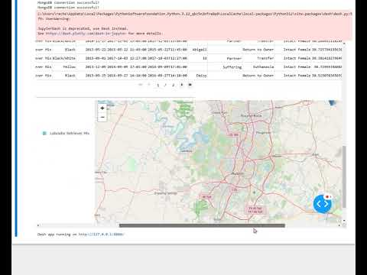](https://www.youtube.com/embed/ylK_wxx5ppI?feature=oembed)When you input ‘q’ the interface will close and move on to the dashboard. Please view the video below to see the dashboard functionality in action! Please set to 720p for best quality

**Screenshots**

1. Uploading a CSV to the database

1. Create a new user



**Contact**

**Your name: Rachel Siminski, Rachel.siminski@snhu.edu**